*Noah Kamphuisen, Twan Asselbergs*

*HashWorks | Happy Herbivore*

*Functional Design*

05-02-2025

Table of Contents

Introduction 1

Purpose 2

Target Audience 3

Functional Requirements 4

UX Design 5

Wireframe 6

Use Case 7

What Isn’t Included 8

**Introduction**

A new startup called ‘Happy Herbivore’ is opening a vegetarian/vegan fast-food restaurant in Hoog Catharijne, Utrecht. They want to run a self-service system as a pilot, but need help from a team of freelancers, because their internal development team is understaffed, and they are working on multiple other projects that also have high priority.

**Purpose**

Like many restaurants in this area, this restaurant is going to use a self service kiosk system, that we are developing for Happy Herbivore. For this reason, and to compete with other local restaurants, they also have to use a kiosk. It’s also very busy around Hoog-Catharijne, so a kiosk system is also a way for the staff to not be under constant stress from the many clients they expect to come in. Next to that, it’s also a good investion in the long term because it will alllow them to have less staff working in the restaurant at one time, saving costs.

**Target Audience**

The target audience for this restaurant primarily consists of young people from Utrecht who are seeking a fast, healthy, and affordable meal. Happy Herbivore mostly serves food to people that prioritize vegetarian and vegan options.

Because the restaurant will be in Hoog Catharijne, it’s expected to attract a very diverse group of customers, including students and young professionals, looking for a quick yet healthy meal. Utrecht is known for its vibrant student population and progressive mindset, making it an ideal city for a vegan fast-food restaurant.

Apart from strict vegetarians and vegans, Happy Herbivore also appeals to flexitarians and health-conscious people who are open to eating more plant-based meals. These customers may not (want to) live a fully vegetarian or vegan lifestyle but are drawn to the restaurant’s fresh and sustainable menu items.

With a good-looking and well-working self-service kiosk system, the restaurant will also appeal to tech-savvy customers who appreciate the efficiency and design of the system.

**Functional Requirements**

There are a few functional requirements for this self-service kiosk system. In summary, we must develop a fully functional prototype for a self-service kiosk that is going to be used to pilot the first Dutch Happy Herbivore restaurant. We will build an attractive idle mode that shows different menu items, think of it like a carousel. The start screen must contain the company logo and must be readable from longer distance. Like mentioned earlier, the menu items must rotate to attract the attention of passing customers.

We will make sure to implement all Happy Herbivore’s menu items, and fuse in their corporate identity. In terms of a payment process, we could simulate it. Eventually, a payment solution partner will be chosen, allowing us to implement it fully.

There are also some optional features, which are up to us if we want to integrate them or not. First off, a language selection feature. This will allow the user to select either Dutch or English for the kiosk. Secondly, we could add data to the menu, allowing the user to toggle between vegetarian and vegan menu items. Finally, we could add fields to the database. This means that after ordering, the order will have its preparation status shown.

To make managing orders easier, we will build a full dashboard, that shows incoming orders and relevant statistics, such as monthly revenue and most ordered products. After a user has placed an order, it will pop up immediately in the dashboard. This way, the kitchen can immediately start preparing it, without needing to reload the page or rely on HTTP polling.

To achieve this feature, we will need to differ from the given tech stack. We have received green light for this. To make integrating the API with the current infrastructure easier, we will provide API documentation, that shows all endpoints and responses. To view the documentation, visit <https://happyherbivore.noeycodes.com/docs>.

**UX Design**

Looking at similar companies, we noticed that most brands use a modern and innovative design language to stand out. While this works for branding, we believe it’s not ideal for a fast-food self-service system, where ease of use is key.

Customers in a hurry don’t want to spend most of their precious time figuring out complex navigation. Instead, we will use a modern UI with a traditional UX, ensuring the system is intuitive and efficient. We will use clear categories, large buttons, and a logical flow to make ordering quick and intuitive for all users.

**Wireframe**

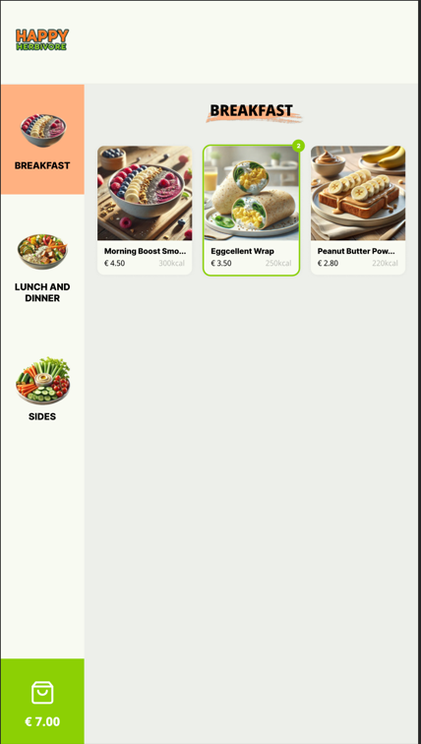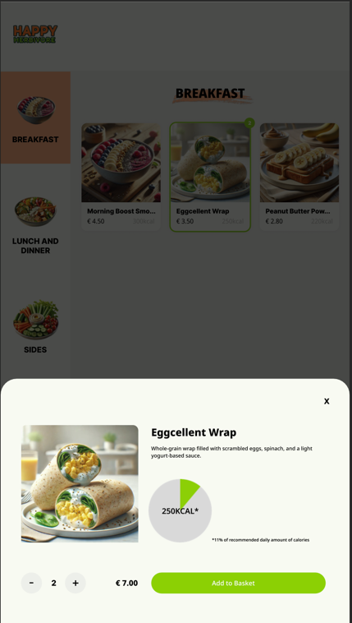

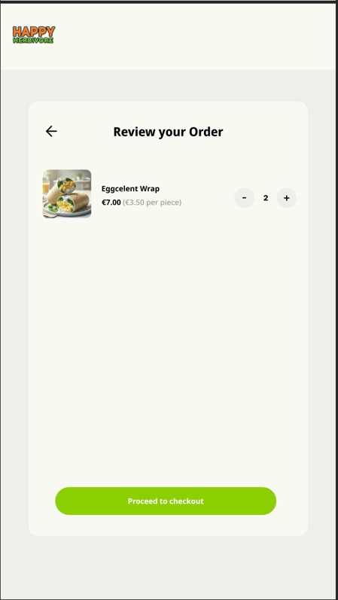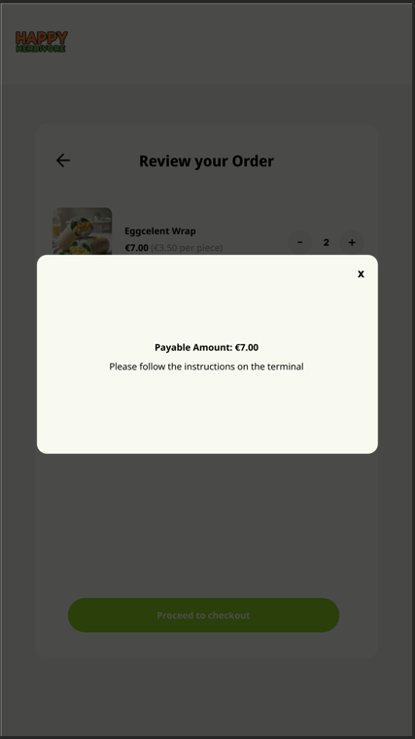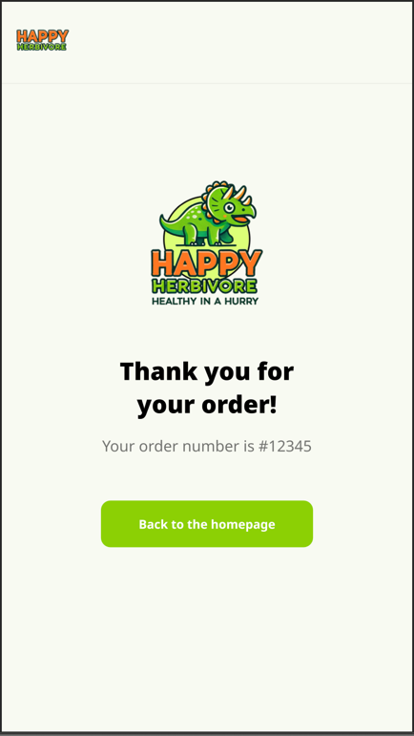

**Use Case**

The use case is used to describe the way users interact with the application. It includes most key interactions of the user flow and can be used to list the steps a user takes to achieve a specific goal (placing an order in this case). It helps with identifying potential issues, improving the user experience, and ensuring that the system meets all user needs.

Alice and Bob arrive at a self-service kiosk to place their food orders. Alice selects a Supergreen Salad, Zesty Chickpea Wrap, and Fruit-Infused Water but later modifies her order by replacing the wrap with Peanut Butter Power Toast. Bob selects a Protein-Packed Bowl, Baked Falafel Bites, and Green Glow Smoothie, later swapping the smoothie for a Berry Blast Smoothie.

After finalizing their selections, they review their order and proceed with payment, totaling €22.60. The kiosk processes their payment and generates a unique order number. The kitchen prepares their meals, and Alice and Bob collect their orders when ready.

The self-service kiosk efficiently facilitates order customization, review, secure digital payment, and order tracking, ensuring a seamless customer experience.

**What Isn’t Included**

Because we are only responsible of developing the application, there are some things that will not be included in the result.

Things that will not be included in the result:

* The payment system. We will simulate this using a timeout for the demo.
* Technical support for issues with hardware; we only provide the software.
* A content management system, for adding, removing, or editing products.
* Hosting for the backend (needs a server that supports Node.js).